
URITECT INC. · PRODUCT GUIDE
What we offer our users
Eight products, one purpose: helping people imagine, improve and enjoy the spaces they live and work in.
Archibi AI · Archibi Find Pro · Brightment · Blink20
Utect 3D · Arch School · ArchNews · CanadaTechNews
October 2026
WELCOME

Spaces shape lives. We help people shape their spaces.
Uritect is a Canadian technology company working where architecture, construction and software meet. Our mission is to bridge the built world with modern technology, so that anyone can imagine a space, understand it, improve it and bring it to life.
We build around four ideas: learning, designing, solving and sharing. Each of our products answers one of them, and together they follow a project from the first spark of an idea to the day the work is done.
This guide walks through every product in turn: who it is for, where to find it, and exactly what people can see and do with it.

One journey, from idea to finished space
Learn  Arch School, ArchNews and CanadaTechNews. | Design  Archibi AI, Brightment and Utect 3D. | Shop  Archibi's Furniture Finder. | Build  Archibi Find Pro professionals, or Brightment's own crew. | Rest  Blink20, for everyone who works at a screen.

Eight products at a glance
PRODUCT | WHAT USERS GET | WHERE | PRICE
Archibi AI | Redesign any space from a photo, shop the look and find a professional | iOS · Android | Free to start; Plus, Pro, Enterprise
Archibi Find Pro | A professional profile that Archibi clients discover | Web | Free to apply
Brightment | Basement egress window concepts, then design, permits and installation | iOS · Android | Free app; $0-down financing for installs
Blink20 | 20-20-20 eye-rest reminders, calming sounds and progress stats | iOS · Android · Desktop | Free
Utect 3D | Home and room design in 3D, in the browser | Web (Alpha) | Free to try
Arch School | Design workshops and a curated video library | Online · Toronto | Free
ArchNews | Architecture, construction and design stories | Web (launching) | Free
CanadaTechNews | News from Canada's technology ecosystem | Web | Free

01 Archibi AI
Design your space like an architect.
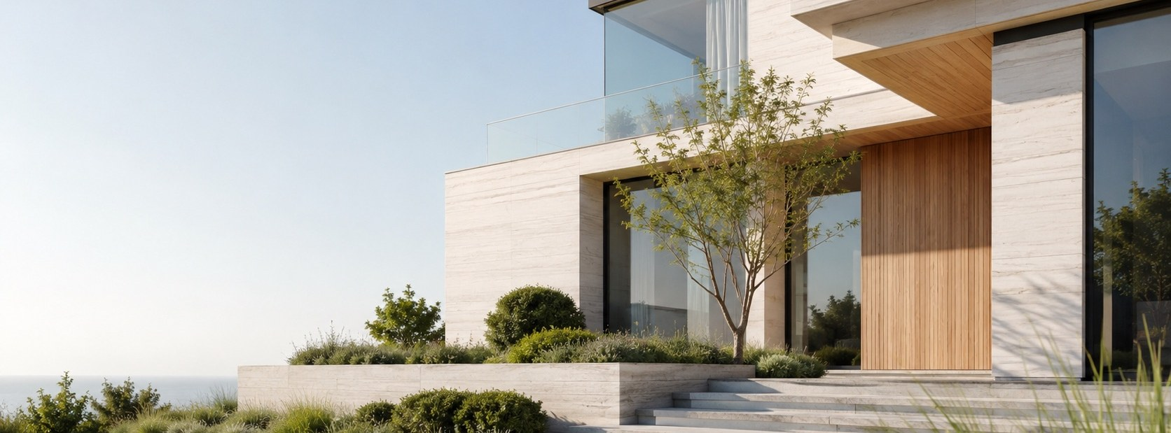
Archibi turns a single photo into a new way of seeing your home. Snap a room, a façade or a backyard, choose a direction, and in moments you are looking at what that space could become. When an idea feels right, Archibi helps you find the furniture to match it and the professionals who can build it.
Archibi is Uritect's flagship product: one app that carries a project from the first idea to the real renovation.
Made for | Homeowners, renters, people preparing a listing, real estate professionals, designers, architects and students
Available on | iPhone and iPad (App Store), Android (Google Play)
Price | Free to start, with Plus, Pro and Enterprise plans
Website | archibi.ca

The Design Studio
The heart of Archibi. Five tools, each one a photo or a sketch away.

Interior
Reimagine any room: living rooms, kitchens, bedrooms, bathrooms, dining areas and home offices. Try new layouts, colours and moods while the room keeps its true proportions and light.

Exterior
Give a house a new face. Test cladding, colours, doors, windows, lighting and landscaping from one photo of the front of the building. Ideal for curb appeal, listings and planning before you call a contractor.

Landscape
Redesign the outdoors. Gardens, backyards, patios and terraces come to life with planting, seating, pathways, outdoor lighting and zones for dining, relaxing or play.

Sketch to Render
Draw an idea by hand, choose a style, and watch it become a realistic architectural image. Made for architects, students and designers who think with a pencil first.

Find Furniture
Love a piece you saw somewhere? Photograph it, or the whole room. Archibi recognises the sofas, tables, chairs, lighting and rugs in the picture and shows similar pieces you can actually buy, with prices and the store selling each one. The catalogue draws on more than 100 stores.

Shaping the result
Every design starts with a few simple choices, and each one is optional beyond the basics.
- Design style. More than 75 styles, from timeless classics to the latest contemporary looks.
- Design mode.
  - Beautiful makes careful changes, staying close to the space's structure and character. Best for practical updates and redecorating.
  - Creative gives the AI freedom to propose something bold: new layouts, new moods, even furnishing an empty room.
- Space type. The kind of room, building or garden you are working on.
- Colour palette. For interiors, pick a ready-made palette of three harmonised colours.
- Materials. Choose finishes for walls, ceilings and floors inside, façades outside, and paths in the garden.
- Your own words. Describe anything else you want, or type your own value in place of a preset. When your words and a preset disagree, your words win.

Your results
Each design opens in a full-screen viewer. From there you can:
- zoom in to study the details,
- download the image to your phone or share it straight away,
- generate another version with one tap,
- and jump to Find a Pro when you are ready to make it real.

Every design is saved automatically to My Projects, and your latest five appear on the Home screen.

Idea Bank
A curated library of interior, exterior and landscape inspiration, chosen by the Archibi team. Browse by room type, style or mood, tap the bookmark to keep an idea in Favourite Ideas, and use it as a starting point for your own design or a reference for your professional.

Find a Pro
When a picture is not enough, Archibi connects you with architects, interior designers and contractors. Browse professionals by section, category and speciality, read their story, explore the projects in their gallery, and contact them directly. Tap the heart to keep someone in Favourite Professionals.
Archibi makes the introduction. Agreements and on-site work are arranged between you and the professional you choose.

Plans
PLAN | PRICE | WHAT IT INCLUDES
Free | $0, no card needed | 5 welcome renders to explore Interior, Exterior and Landscape design, Beautiful and Creative modes, the Idea Bank, Furniture Finder and Find a Pro. Personal use.
Plus | $6.99 a month, or $59.99 a year | 90 renders a month, the full style library and watermark-free HD downloads. Personal and household use.
Pro | $29.99 a month, or $249.99 a year | 450 renders a month, full Sketch to Render, high-resolution and 4K downloads, priority processing, commercial usage rights and a longer project history.
Enterprise and Teams | By arrangement | Shared render pools, multiple seats with central billing, a dedicated queue, custom style presets, commercial licensing and integration options.

Prices are as published on archibi.ca/pricing.
Need more renders? Top-up packs can be bought at any time. Your plan's renders are used first, then top-ups, starting with the ones closest to expiring.

Your account
- Plan and Billing: see how many renders you have left, when your plan renews, and buy more renders.
- Manage Plan: your allowance, your top-ups and their expiry dates, and a direct link to manage your subscription through Apple, Google Play or card.
- Purchase History: every purchase in one place.
- Projects and Favourites: My Projects, Favourite Ideas and Favourite Professionals.
- Help and Support: the user guide, FAQ, feedback and a direct line to support@archibi.ca.
- Privacy and Data: clear privacy controls and account deletion. A deleted account is held for 30 days, so you can change your mind by simply signing in again.

Sign in with email, Google or Apple.

Getting started
- Download Archibi and create your free account.
- Open the Design Studio and pick Interior, Exterior, Landscape, Sketch or Furniture.
- Add a photo or a sketch, choose a style and a mode, and generate.
- Save, share, shop the look, or find a professional to build it.

Good to know
Archibi's images are concept visualisations. They help you decide and communicate; they are not construction drawings, and they may not reflect exact dimensions, materials or structural requirements.
App Store: apps.apple.com/ca/app/uritect/id6756135453
Google Play: play.google.com/store/apps/details?id=uritect.com.main
Instagram: @archibi.ca · TikTok: @archibi_ca
Archibi AI is developed and operated by Uritect Inc.

02 Archibi Find Pro
Build your practice with Archibi.

Every Archibi design ends with the same question: who can build this? Find Pro is where that question meets its answer. Architects, interior designers and contractors create a profile, show their best work, and are discovered by clients who already know what they want.
Made for | Architects, interior designers, contractors and other building professionals
Available on | The web, at pro.archibi.ca
Where clients see you | The Pros tab and Find a Pro in the Archibi app
Price | Free to apply

What a professional can do

Apply in one guided form
Tell your story once and let your work speak for you:
- your name, profession, contact email, phone and website;
- a profile photo, plus a banner and cover image that set the tone;
- the sections and categories you work in, and up to 12 tags that describe your expertise;
- your location, so nearby clients can find you, and the days you are available each week;
- your CV and any supporting documents;
- your projects, each with a title, a description and images;
- and an optional note for the review team.

Each application receives a case number, so you always know where it stands.

Pass a quality review
Every application is read by the Archibi team before it goes live. You will see whether your profile is pending review, accepted or needs changes. If something is missing, update your application and send it back.

Run your profile
Once accepted, your profile becomes your shop window inside Archibi:
- edit your details, images, expertise and documents at any time;
- add, edit or remove projects as your portfolio grows;
- manage your password, appearance and account from Settings.

What clients see
Inside the Archibi app, clients browse professionals by section, category and speciality. Your profile shows who you are, what you do, the tags that define your work and a gallery of your projects. Clients can save you to their favourites, share your projects, and contact you with a single tap.
Archibi makes the introduction. Agreements, quotes and on-site work are arranged directly between you and your client.

Getting started
- Visit pro.archibi.ca and choose Join as a professional.
- Complete the application and verify your email.
- Wait for the team's review, then sign in to manage your profile.

Already a member? Sign in.
Archibi Find Pro is part of Archibi AI, developed and operated by Uritect Inc.

03 Brightment
More light. More safety. More value.
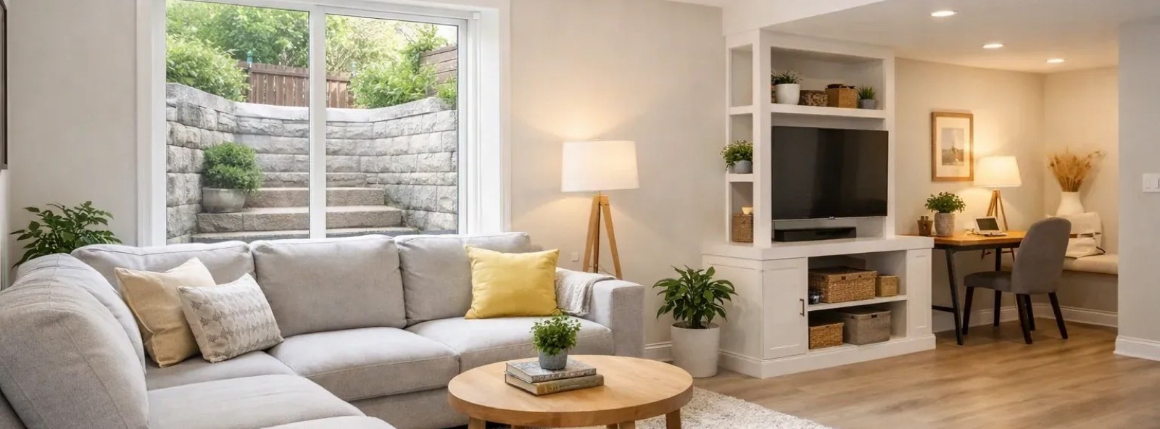
Too many basements are dark, uncomfortable and, in an emergency, hard to leave. Brightment changes that with a well-designed egress window: the large, code-compliant window that brings daylight downstairs and gives everyone in the room a real way out. It is often the difference between a storage cellar and a bedroom, a rental suite or a family room.
Brightment pairs a free design app with a full installation service. You see the result first, then one team makes it happen.
Made for | Homeowners who want a brighter basement, a legal bedroom or rental suite, or a safer home
App available on | iPhone and iPad (App Store), Android (Google Play)
App price | Free, with complimentary design credits when you sign up
Service | Design, permits and installation across Canada
Website | brightment.ca

The Brightment app: see it before you dig
Photograph the basement window you have today and receive a realistic picture of what it could become, in your own space.

Interior Design: see your basement with real daylight
Take the photo from inside the room. The furniture, floor and walls stay as they are; the wall opens into a full egress window with sunlight across the room. Choose:
- Window style: slider, casement, hopper, or fixed with casement;
- Frame finish: white, almond, black or woodgrain;
- Light: bright midday, soft morning or warm afternoon.

Exterior Design: see the window well and landscaping before you dig
Take the photo from the yard. The siding, roofline and driveway stay untouched; only the basement opening and the ground around it change. Choose:
- Window style and frame finish, as above;
- Window well: corrugated galvanized, stacked stone, poured concrete or composite;
- Landscaping: minimal, planted border, rock garden or full landscape.

Add a note about anything else you would like to change, then generate.

Your projects and account
Every concept is saved to My Projects, where you can zoom in, download and share it. Your account keeps your credits, profile and password in one place, and you can delete it at any time. Sign in with email, Google or Apple.

The Brightment service: one team, start to finish
When you are ready, Brightment takes care of the whole job:
- Site assessment to confirm the design in person, because egress requirements vary by property and province.
- Design and engineering of the window and well.
- Permits, applied for on your behalf.
- Excavation, foundation cutting and installation.
- Window well and landscaping, finished to match your concept.

Most single-window installations are completed in one day once the permit is in hand.

Why homeowners choose Brightment
- Safety: a code-built emergency exit for everyone downstairs.
- Value: a basement that can legally become a bedroom or a rental suite.
- Light: more daylight for a healthier, more comfortable space.
- Simplicity: one point of contact instead of a chain of contractors.

Financing
Upgrade with $0 down and simple monthly instalments, through an approval-based plan with Brightment's financing partner.

Good to know
The app's images are design visualisations, not engineering drawings. Every project is confirmed by a site assessment before work begins.
App Store: Brightment: Bright Basement
Google Play: play.google.com/store/apps/details?id=brightment.main.app
Instagram: @brightment.ca
Brightment is a Canadian company and a property of Uritect Inc.

04 Blink20
Focus. Rest. Protect.

Long days in front of a screen leave their mark on the eyes. Blink20 is a gentle, private companion built on the 20-20-20 rule that optometrists recommend: every 20 minutes, look at something 20 feet away for 20 seconds. It keeps time so you don't have to, and turns a healthy habit into an effortless one.
Blink20 began inside Uritect, as a tool for our own team. It helped us so much that keeping it to ourselves felt wrong, so we made it free for everyone.
Made for | Anyone who spends long hours at a screen: developers, designers, students, office and remote workers
Available on | iPhone and iPad, Android, and desktop (macOS on Apple Silicon, Windows, Linux)
Price | Free. No account, no ads, no in-app purchases
Languages | 21
Website | blink20.com

What you can do

Start a focus session
Press Start and get back to work. Blink20 counts down to your next break and lets you know how long is left.

Take a real break
When it is time, a calm rest screen asks you to look 20 feet away and counts down the seconds. A relaxing soundscape can play while you rest. Need to keep going? Hold to skip.

Make it yours
- Reminder interval: how often you are reminded to rest.
- Resting duration: how long each break lasts.
- Relaxing sound: nature, fire, sea or waterfall, your own audio file, or silence.
- Quiet hours: no reminders during the hours you choose.
- Dark mode: a low-light palette that is easy on tired eyes.
- Language: 21 languages, including English, French, Spanish, Arabic, Persian, Hindi, Chinese and Japanese, or follow your device.

See your progress
The Stats screen shows how much you rested today, this week, this month and this year. Charts break it down by hour, day, date or month; tap any bar for the details. Your session count, averages and your streak of consecutive days keep you motivated.

Private by design
Everything Blink20 does happens on your device. There is no sign-up, no tracking and no data collection, and it works without an internet connection.

Getting started
- Download Blink20 for your phone or computer.
- Follow the three-card introduction and allow notifications, so reminders can reach you.
- Press Start. Blink20 takes care of the rest.

Good to know
Blink20 supports healthier screen habits. It is not a medical device and does not diagnose or treat any condition. If your eyes trouble you, please see an optometrist.
App Store: apps.apple.com/ca/app/blink20/id6790842122
Google Play: play.google.com/store/apps/details?id=blink20.main.app
Desktop: blink20.com
Support Blink20: buymeacoffee.com/blink20
Blink20 is made with care by Uritect Inc.

05 Utect 3D
Simple 3D design for the built world.
Some ideas need more than a picture; they need a space you can walk around. Utect 3D is a design engine that opens in your web browser and lets you shape a whole home, or a single room, in three dimensions. No software to install and no design experience required.
Made for | Homeowners, first-time designers, and owners planning an office or a store
Available on | Any modern web browser, at uritect.com/unity
Price | Free to try
Status | Alpha: open for early users and their feedback
Website | uritect.com/utect3d

What you can do
- Design a complete home or a single room. Lay out the space and see it from every angle.
- Arrange furniture. Place pieces, move them around and find the layout that works.
- Choose materials. Try finishes and surfaces until the space feels right.
- Generate realistic renders. Turn your 3D scene into a lifelike image to share.
- Design with real products. Visualise your space with furniture you can actually buy.
- Plan workspaces and shops. Shape offices and stores that are practical for the people who use them and inviting for customers.

Working with partners
Utect 3D is also a doorway to building. Uritect works with partners who can turn a finished design into a real home, and we welcome prefab home manufacturers in Canada and North America who would like to collaborate.

Help shape what comes next
Utect 3D is in Alpha, and early users have a real say in where it goes. Try it, then tell us what you think through the feedback form on the Utect 3D page. Every piece of feedback earns a complimentary coffee on us.

Getting started
- Open uritect.com/unity in your browser.
- Start a room or a home and begin arranging.
- Share your feedback from uritect.com/utect3d.

Utect 3D is developed by Uritect Inc.

06 Arch School
Free design education for women.
Good design should not be a privilege. Arch School is Uritect's non-profit education initiative, created to make architecture, interior design and spatial thinking open to everyone, with a special focus on women and other groups who are underrepresented in the field. Women hold founding and key roles at Uritect, and Arch School is how we pass that opportunity forward.
Made for | Beginners and curious minds, especially women and underrepresented learners
Format | Live workshops, online and in Toronto, plus a free video library
Price | Free
Website | uritect.com/arch-school

Workshops
Arch School runs short, practical workshops under Uritect's Empowering Women programme, including free one-day courses in Toronto and live online sessions.

Featured workshop: Basic Concepts of Interior Design
A two-hour, women-only online class that teaches how to see a room the way a designer does.
- You will learn: space planning and layout, balance and proportion, colour harmony, lighting, and choosing materials, and how to apply each of them to a real room with simple tools.
- You will receive: a structured lesson with visual examples, practical tips for your home or future projects, and a short class project.
- You will earn: a certificate when you complete the project.

Places are reserved through Eventbrite, linked from the Arch School page.

Design Foundations video library
A growing collection of theory lessons, hand-picked by the Uritect team from respected design educators:
LESSON | WHAT IT COVERS
8 Decorating Rules You Should Never Break | Balance, proportion, rhythm and harmony
Interior Design Space Planning 101 | Mapping a space, traffic flow, focal points and circulation
50 Interior Design Styles Explained | A tour of styles from Art Deco to Japandi
Lighting Design 101 | Layering ambient, task and accent light
Free Colour Training Lesson | Choosing whites and neutrals, reading undertones, building a palette

New lessons are added over time.

Join us
- Visit uritect.com/arch-school.
- Reserve a place in the next workshop, or start with the video library today.
- Complete your class project to earn your certificate.

Arch School is a non-profit initiative of Uritect Inc., University of Toronto, Schwartz Reisman Innovation Campus, 108 College St., Suite W754, Toronto.

07 ArchNews
The built world, one story at a time.
Architecture shapes how we live, work and gather, yet its best stories are often scattered across trade journals and specialist sites. ArchNews brings them together. It is Uritect's publication for architecture, design, construction, cities and materials from around the world, written for professionals and curious readers alike.
Made for | Architects, designers, builders, students, and anyone who cares about the spaces around them
Available on | The web, at archnews.ca
Price | Free to read
Status | Alpha: the new site is being prepared for launch

What readers will find
- Architecture and design: notable projects, new ideas and the people behind them.
- Construction: methods, technology and the realities of building today.
- Cities: housing, planning and how communities grow.
- Materials: what our buildings are made of, and what they could be made of next.

Part of a bigger conversation
ArchNews continues the writing Uritect has long shared on its own blog, from the psychology of home design and the value of interior design in residential construction to the role of prefabricated homes in Ontario's housing challenge.

Stay tuned
The new ArchNews is on its way. Visit archnews.ca to see it as soon as it goes live, and read past articles at uritect.com/blog.
ArchNews is published by Uritect Inc.

08 CanadaTechNews
Tech trends with a Canadian lens.
Canada's technology story is being written every day, from AI start-ups in Toronto to clean-energy innovators in Vancouver. CanadaTechNews follows it closely: the companies, the founders, the research and the decisions shaping the country's tech ecosystem.
Made for | Founders, investors, engineers, students and anyone following Canadian technology
Available on | The web, at canadatechnews.ca
Price | Free to read

What you can read
SECTION | COVERAGE
Startups | New companies, launches and the founders behind them
AI | Artificial intelligence research, products and practice
Industry Sectors | How technology is changing Canadian industries
Ecosystem and Community | Accelerators, hubs, meet-ups and the people who connect them
Innovation and Research | Breakthroughs from labs and universities
Events | Coverage of the gatherings where the ecosystem meets
Policy and Government | Regulation, investment and public decisions that affect tech

Alongside the sections, the homepage brings together breaking news, editor's picks, trending stories, voices from founders, business news and international headlines.

Recent coverage
Recent stories include reporting from Toronto's start-up gala scene, the Alberta and federal agreement on AI data centres, and practical guides for developers working with modern AI tools.

Follow along
Read at canadatechnews.ca, search the archive by topic, and follow CanadaTechNews on LinkedIn.
CanadaTechNews is published by Uritect Inc.
GET IN TOUCH
We would love to hear from you.
Uritect Inc.
University of Toronto, Schwartz Reisman Innovation Campus
108 College St., Suite W754, Toronto, ON, Canada
(437) 800-0845 · uritect.com/contact-us
uritect.com · archibi.ca · brightment.ca · blink20.com · canadatechnews.ca · archnews.ca
© 2020–2026 Uritect Inc. All rights reserved. Proudly Canadian. Product details are accurate as of October 2026; plans and prices are as published on each product's website.

